PERFORM ROOTKIT DETECTION AND REMOVAL 231901005

USING RKHUNTER TOOL

AIM:

Perform real-time file system analysis on a Linux system to identify an attacker's artefacts. TASK 2 : INVESTIGATION SETUP

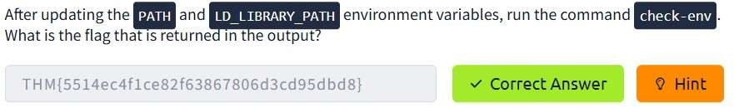

TASK 3 : FILES,PERMISSION AND TIMESTAMPS

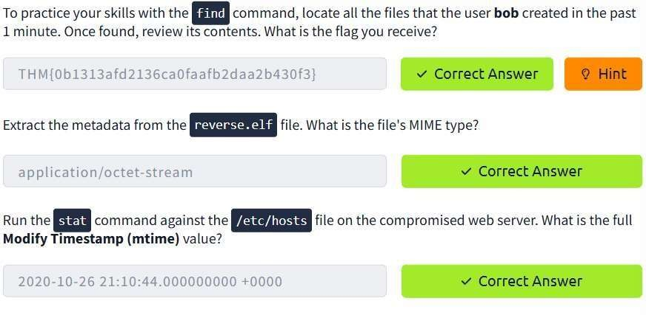

TASK 4 : USERS AND GROUPS

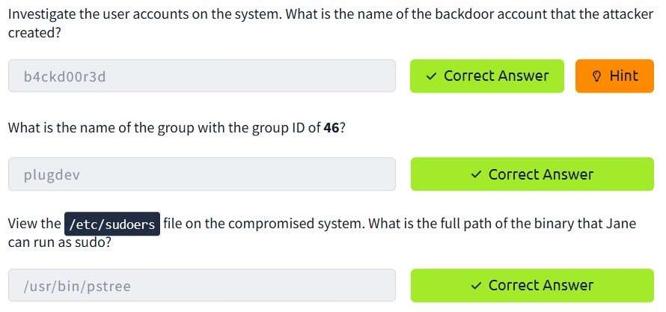

TASK 5 : USER DIRECTORIES AND FILES

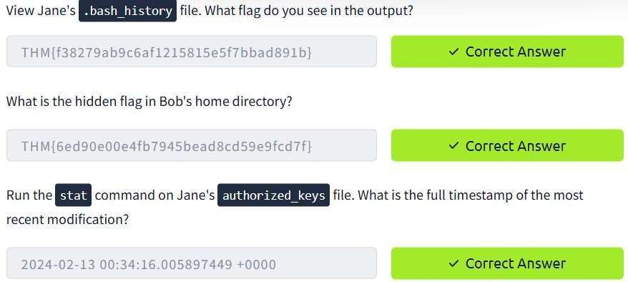

TASK 6 : BINARIES AND EXECUTABLES

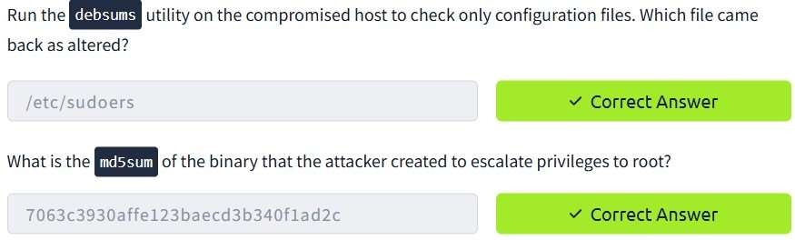

TASK 7 : ROOTKITS

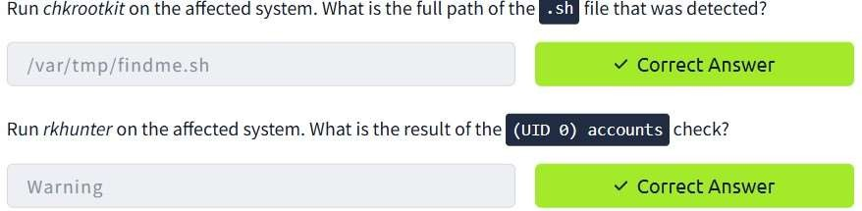

CONCLUSION :

Rootkit detection and removal using rkhunter tool is successfully performed.